
AIDACARE MICROSOFT DYNAMICS GP INFRASTRUCTURE DOCUMENTATION
Aidacare IT Department
Document Owner: Arthur Achilleos
QR-IT-INF-001 V0.1

Revision History:
Sr# | Date | Actor | Comments
0.1 | 25th Sep 2025 | Maksud | Created

Table of Contents
1. Introduction 2
2. Deployment Model 3
3. Servers and Operating Systems 4
3.1 Application & Database Servers 5
3.2 Hardware Specifications 6
3.3 Supporting Servers 6
4. Network and Security Architecture 6
5. Database Infrastructure 7
6. Integration and Middleware Hosting 8
7. Monitoring and Maintenance 9
8. Disaster Recovery and Business Continuity 10
9. Future Infrastructure Improvements (Planned) 11
10. Compliance and Governance 12
11. Future Improvements and Roadmap 13

1. Introduction
This document describes the infrastructure architecture supporting the Microsoft Dynamics GP (MS-GP) ERP system at Aidacare. It provides technical details about the hosting environment, network setup, server specifications, database configurations, integration architecture, and operational support for the ERP platform.

Best Practice:
Sr# | Type | Description | Comments
1 | System & Infrastructure | Implement High-Availability (HA) and Disaster Recovery (DR) solutions for MS-GP and SQL servers to minimise downtime and ensure business continuity. | Regularly test failover and backup procedures to ensure reliability.

2. Deployment Model
Aidacare’s MS-GP ERP system is deployed on-premises within Aidacare’s data center infrastructure. The deployment supports core business operations across finance, procurement, inventory, and sales processes.
- Hosting Location: Aidacare Data Centre (On-premises)
- Access Method: Users access the ERP environment via Citrix, followed by Remote Desktop Connection (RDC) to the application servers.
- Environments: Multiple environments exist including Development, Test, and Production. Each environment has its own dedicated server/database instance.

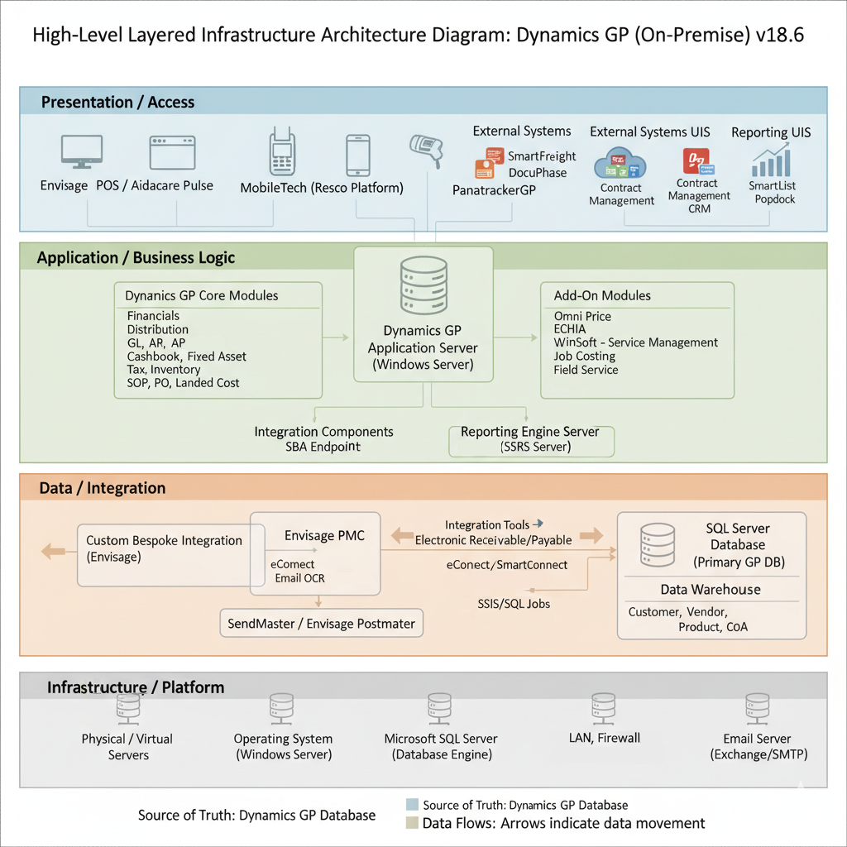Best Practice:
Sr# | Type | Description | Comments
1 | Controlled Access | Access ERP via Citrix and Remote Desktop Connection (RDC) only; restrict direct server access | Ensures secure and monitored access to production systems

3. Servers and Operating Systems

3.1 Application & Database Servers
- Primary Server Name: AIDAGPDEV01V (10.26.21.43), AIDADC02V (10.26.21.4)
- Operating System Name: Microsoft Windows Server 2019 Datacenter
- Operating System Version: 10.0.17763
- SQL Server Version: Microsoft SQL Server 2019 (Developer Edition, 64-bit,15.0.4445.1)
- GP Client Version: 18.6.1728
Installed Applications and Versions
# | Application | Version
1 | Citrix Virtual Apps & Desktops | 2203 LTSR
2 | Microsoft Dynamics GP | 18.0.1739.000
3 | Wennsoft Signature Equpment Management 2015 R | 14.0.2.0
 | Dexterity for Microsoft Dynamics GO 2018 | 18.00.0028.000
4 | MobileTech | NA
5 | POS (Envisage Software) | 4.0.2
6 | HR3 (ReadyTech) | NA
7 | Panatrack | V7
8 | SmartConnect (eOne Solutions) | 21.1.0.10
9 | Management Reporter | NA
10 | Popdock | NA
11 | Smart Freight | NA
12 | Freight Master | 4.0.0
13 | Docuphase (OnPhase) | NA
14 | SmartView | 2.0.70
15 | Goliath Monitoring | NA
16 | Unitrend Backup | NA
17 | Metalogix (Quest Software) | NA
18 | File Servers | N/A
19 | Domain Controller | N/A
20 | Active Directory | N/A
21 | Exchange Server | NA
22 | Service Desk (ManageEngine) | NA
23 | Endpoint Central (ManageEngine) | NA
24 | Aidacare Reports | N/A

3.2 Hardware Specifications
- CPU: Intel Xeon Gold 6326 @ 2.90GHz, 6 vCPUs (host has 16 cores / 32 threads)
- RAM: 20 GB
- Disk Configuration:
  - B: 500 GB SSD – 220.84 GB free
  - C: 350 GB SSD – 27.39 GB free
  - D: 1000 GB SSD – 337.56 GB free
  - All drives are SSD
- Storage Capacity: 1849.89 GB usable

3.3 Supporting Servers
- 12 Citrix Virtual Delivery Agents (VDA servers)
- Dedicated file servers for shared folders
- Backup servers for BCP/DR and archiving

Best Practice:
Sr# | Type | Description | Comments
1 | Dedicated & Redundant Servers | Maintain dedicated servers for application, database, Citrix VDAs, file storage, and backup/DR | Supports performance, reliability, and disaster recovery readiness

4. Network and Security Architecture
- Network Topology:
  - No direct database or application exposure to the external internet (no DMZ).
  - Secure communication channels include SSL/TLS for web services and OData endpoints.
- Access Control:
  - Role-based access controls are enforced within GP.
  - Planned implementation of Multi-Factor Authentication (MFA) for Citrix access in late 2025.

- Security Controls:
- Antivirus: Defender for Endpoint; signature update frequency
- Patch Management: Quarterly via [Tool/Team]
- Penetration Tests: [Frequency, last test date]
- Audit Logging: [Tool used, what events logged]
- Encryption: TLS/SSL used for all communication; TDE at rest
- Vulnerability Management: [How are servers scanned and remediated?

- Service Accounts & Middleware:
  - Service accounts exist with least privileges for integration tools such as SmartConnect, eConnect, and PanatrackerGP.
  - SSL certificates for web components are centrally managed.

Sr# | Type | Description | Comments
1 | Network & Access Control | No direct database/application exposure to internet; role-based access controls enforced via GP ; MFA planned for Citrix access | Reduces attack surface and strengthens authentication

5. Database Infrastructure
- Databases:
  - 27 databases related to MS-GP including core ERP, integrations, reporting, and auditing.
- SQL Server Configuration:
  - Use of Transparent Data Encryption (TDE) for critical DBs like DYNAMICS and HANDR.
  - Windows Authentication only for SQL access.
- Backup and Recovery:
  - Backups are being placed with SQL Agent Jobs for full, differential, and log backups.
  - Backup Types: Full (daily), Differential (hourly), Logs (15 mins)
  - Backup retention is 7 years with encrypted offsite storage.
  - Storage: Encrypted offsite via [Backup Tool/Media Type/Location]
  - Verification Process: [How/when are backups tested?]
  - Recovery Point Objective (RPO): 15 minutes
  - Recovery Time Objective (RTO): 4 hours
- SQL Agent Jobs:
  - 52 jobs for maintenance, integrations, and monitoring run regularly (e.g., integrity checks, index optimisation).
Best Practice:
Sr# | Type | Description | Comments
1 |  | Use Windows Authentication only for SQL access; implement Transparent Data Encryption (TDE) for critical databases | Ensures secure access control and protects sensitive data at rest
  Database Security & Access

6. Integration and Middleware Hosting
- SmartConnect Middleware: Runs on dedicated servers within the same on-premises infrastructure. It manages all integration between GP and external/internal systems via batch and real-time jobs.
- eConnect: Installed on-premises, invoked through SmartConnect, also no direct database connectivity allowed from third systems.
- Other Integrations: OData, REST APIs, SQL Jobs, and file-based shared folders are hosted within the infrastructure supporting data interchange.

Best Practice:
Sr# | Type | Description | Comments
1 | Middleware Isolation | SmartConnect and eConnect run on dedicated on-premises servers; no direct database connectivity for third-party systems | Ensures controlled access and reduces risk from external integrations

7. Monitoring and Maintenance
- Monitoring Tools: [e.g. SQL Agent, SCOM, Nagios, SolarWinds]
- Logs Tracked: SQL performance, SmartConnect failures, disk usage
- Alerts: Sent via [Email/SMS/Ticketing system]; threshold config
- Patch Schedule: Quarterly; tested in Dev/UAT
- Antivirus/Endpoint Protection: [Vendor]; Auto-updates enabled
- Maintenance Activities: Indexing, DBCC CHECKDB, Cleanup jobs

Best Practice:
Sr# | Type | Description | Comments
1 | Scheduled Maintenance & Patch Management | Quarterly patching schedule tested in Dev/UAT; routine maintenance activities like indexing, DBCC CHECKDB, cleanup jobs; antivirus/endpoint auto-updates | Ensures system stability, performance, and security

8. Disaster Recovery and Business Continuity
- Offsite Backup: Stored in [Location], encrypted, verified
- DR Testing: Annual recovery drills (last: [Date])
- Failover Mechanism: None currently; exploring clustering or Always On
- BCP Document: Located at [internal doc path]; defines critical apps & recovery priority

Best Practice:
Sr# | Type | Description | Comments
1 | Offsite Backup & Encryption | Backup data stored offsite, encrypted, and verified | Ensures data availability and security in case of local failures

9. Future Infrastructure Improvements (Planned)
- Support Teams: Infrastructure, DBA, App Support, Network/Security
- Escalation Path: Level 1 > Level 2 > Vendor
- On-call Coverage: [Y/N], after-hours support availability

Best Practice:
Sr# | Type | Description | Comments
1 | On-call & After-hours Support | On-call coverage and after-hours support availability | Provides continuous operational support and minimises downtime

10. Compliance and Governance
- GDPR: Masking policy for non-prod data sets
- Audit Logs: Retained for [X years]
- Access Review: Quarterly reviews of privileged accounts
- Policy Framework: [ISO27001/NIST/Other]
Best Practice:
Sr# | Type | Description | Comments
1 | Data Privacy & GDPR | Mask Personally Identifiable Information (PII) in non-production environments | Ensures compliance with GDPR and protects sensitive data

11. Future Improvements and Roadmap
- Migration planning to Windows Server 2022 and SQL Server post-2029
- MFA rollout for Citrix via [Tool]
- Cloud-based DR/HA architecture exploration (e.g., Azure Site Recovery)
- Automation of integration monitoring and alerting

Best Practice:
Sr# | Type | Description | Comments
1 |  | Automate integration monitoring/alerting; explore cloud-based DR/HA (e.g., Azure Site Recovery) | Improves operational efficiency, reduces manual errors, and strengthens disaster recovery
  Automation & Cloud DR/HA

